
Thought Technology Ltd.

Connection Instrument

Software Development Kit
Version 6.8.0

November 19, 2020

Thought Technology Ltd.
5250 rue Ferrier
Suite 812
Montréal, Québec,
Canada, H4P 1L3.

Table of Contents

1 Introduction 3
2 Changes in this version of SDK. 4
3. Programming Notes. 5
4 SDK folder structure. 6
5 Description of the functions exported by ConnectionClient.dll 7
6 Sample applications. 9
6.1 Test Client: An example of implementation. 9
6.1.1 General notes 9
6.1.2 Actual Implementation. 10
6.2 SampleFlash Player. 11
6.2.1 Necessary modifications to Flash movies. 13
7 Using your application with Biograph. 16
7.1 General principals of integrating with Biograph. 16
7.2 Creating game XML file. 18

Introduction

The objective of this project is to provide third-party applications (TPA) possibility to connect to a network or local computer which is running Biograph and read signals from Instruments during Recording or Replay.

To accomplish desired communication, we created a ConnectionClient.dll that has a set of APIs which can be used to connect to a computer running Biograph and get requested data from it with the help of Connection Instrument. The whole functionality was implemented using Windows Sockets 2.
In existing design, it is possible to run Biograph on one PC and then start a game on the same PC and/or on another PC on the network. Biograph would act as server (or Producer) and game(s) will be client(s) (or Consumer(s)). For now, it is possible to establish a connection only from a Game to Biograph.
This document is intended for development of the games that can be used only with Biograph Version 6.0 or greater. To create a game that would work with Biograph version 5.1 or smaller, you must use older version (3.0.3) of Connection Instrument SDK.
Please note that we always try to support game designed with older SDK. However, to get new functionality, you would need to have Biograph greater than 5.1 and design your application according with instructions from this SDK.

Changes in this version of SDK.

For detailed Change History of SDK, please read SDK History.htm which is located in Documentation folder of this SDK.
3. Programming Notes.

Before going into details, it is necessary to explain the general design principals of Connection Instrument SDK.
Biograph uses TTConnectionServer.dll to act as server. As Biograph is 32-bit version application it uses 32-bit version of TTConnectionServer.dll.
Clients use ConnectionClient dll to act as TCP clients. Connection Instrument SDK contains both 32 and 64-bit versions of ConnectionClient dll.
In this SDK, there 4 sample projects: TestClient, SampleFlashPlayer, VbTestClient and VcTestClient.
VbTestClient is a 32-bit Visual Basic project that uses 32-bit ConnectionClient.dll.
The other 3 samples are written in C++ and have both 32 and 64-bit versions working with 32 or 64-bit version of ConnectionClient dll correspondently.
More detailed explanations of TestClient and SampleFlashPlayer can be found in this document. However there is no additional description of VbTestClient and VcTestClient sample projects as they are very simple. All necessary explanations can be found inside the comments of the source code files of those respective samples.
Also, in this SDK there is Server Simulator program (ServerSimulator.exe) that imitates Biograph. This program can be found in Utilities folder and could be used to test a sample project or any other client applications designed with ConnectionClient.dll.
Another important note: when you distribute your game to be used with Biograph, always make sure that your game uses the same dll it was developed with. By other words, you have to redistribute ConnectionClient dll. It is supposed to be the same dll that came with SDK you have been using. This way there would be no confusion or unexpected results. But never overwrite ConnectionClient.dll that came with Biograph!

SDK folder structure.

Connection Instrument SDK folder consists of 4 subfolders: ConnectionTools, Documentation, Samples and Utilities.
ConnectionTools folder contains headers and libraries necessary for provided samples and for your own projects.
Documentation folder contains this document and SDK history html file.
Samples folder contains all 4 sample projects with source codes (TestClient, SampleFlashPlayer, VbTestClient and VcTestClient). Also Samples folder contains bin subfolder. The bin contains x64 subfolder and 32-bit version files of ConnectionClient dll and all 4 sample executables with their xml files. x64 subfolder contains 64-bit versions of ConnectionClient dll and C++ samples (TestClient, SampleFlashPlayer and VcTestClient).
Utilities folder contains Server Simulator program that can be used to test Sample applications without running Biograph session. Another program in this folder is AddPath.exe which creates and updates tag <Path> in the XML file.

Description of the functions exported by ConnectionClient.dll

Here is some information on how data transfer works and at what sampling rate. Biograph (thru Connection Instrument (CI)) sends data out to connected clients 16 times per second. Before sending, Connection Instrument adjusts its data buffer to the sampling rate of 64 samples per second. For example, if CI gets a buffer of size 128 samples 16 times per second, the CI (before sending out) down samples buffer to 4 samples; and then sends out 4 samples. And it does it 16 times per second the same way. When a ConnectionClient dll gets these values it stores last value and also keeps track of min and max values for each buffer it gets. Client could read the whole arrays or only the last values. cxcGetStates function allows to read the last action samples. cxcGetActionData function allows to read the whole array. So, to get the best refresh rate of the last signals data, the clients could call cxcGetstates and / or cxcGetActionData functions up to 16 times per second. There is no need to call it more often, as there is no new data anyway.

BOOL cxcInitialize( long nCxcVersion )
This is the first function you must call before connecting to Biograph. This function makes a call to WSAStartup that initiates use of WS2_32.dll.
nCxcVersion – is API version. Usually equals to CXC_VER (from ConnectionClient.h).

BOOL cxcGetVersion( long * pnVersion )
Returns the API version of loaded ConnectionClient.dll.

void cxcTerminate( void )
This is the last function you must call. This function makes a call to WSACleanup().

BOOL cxcSetPort( long nPort )
Sets the TCP port number to make connection to. Must be the same port number used by Server. Default value is TCP port 1000.

BOOL cxcConnect ( LPCSTR szServer )
Attempts to connect to a server with specified IP.

BOOL cxcGetClientId( long * pnClientId )
Returns Client ID associated with current session.

BOOL cxcGetSessionMode ( long * nSessionMode)
Returns Session Mode associated with current session. Possible values: Replay or Recording.

CXC_RESULT cxcGetStates(CXC_ACTION_STATE * pStates, int * pcStates, int iStart)
Returns signals data; where pStates is an array that would be filled with signals data; pcStates indicates last element of an array to update, and iStart is first element in pStates to update.

BOOL cxcGetFormats(CXC_ACTION_FORMAT * pFormats, int * pcFormats, int iStart)
Returns all formats (min, max, thresholds) that correspond to signal data; where pFormats is an array that would be filled with latest data; pcFormats indicates last element of an array to update, and iStart is first element in pFormats to update.

BOOL cxcGetSessionState( long * pnSessionState )
Returns current Session state (Running, Stopped, Paused, Frozen).

void cxcDisconnect( void )
Disconnects this client from Server.

Please note that we have special “GOT” flags that indicate when a particular element has been changed. The possible flags are:
CXC_GOT_NEW_STATE
, CXC_GOT_CLIENTID
, CXC_GOT_FORMAT
, CXC_GOT_START
, CXC_GOT_RESUME
, CXC_GOT_SESSION_STATE
, CXC_GOT_SESSION_MODE .
You do not have to use them if you do not need them. We thought they could be useful for some applications. In fact, all our samples demonstrate how to use them.
BOOL cxcGetActionData( int iAction
, int cBufferSamples
, CXC_SAMPLE * pBuffer
, int * pcDataSamples
, int * pcLostSamples
)

where:
cBufferSamples - size of buffer, in samples;
pBuffer - pointer to buffer, cannot be NULL;
pcDataSamples - count of data samples returned in buffer, cannot be NULL;
pcLostSamples - count of samples overwritten by newer samples, can be NULL if don't care.

The function returns FALSE if an error happened, otherwise returns TRUE.

Sample applications.

Please note, that TestClient and SampleFlashPlayer are missing full paths in the respective XML files. In order to start provided sample applications from Biograph, you must add a full path to the executable in XML file (tag <Path>). For more information see Creating game XML file. Or you can use AddPath.exe to do it. Open this application and browse for executable file and then full path would be added into XML file. This can be done manually as well.

Test Client: An example of implementation.
This section explains how to develop your own game that can be used with Biograph. First of all, you will need ConnectionClient.dll (and lib) and ConnectionClient.h files to compile your project.

General notes

To begin with, you can have a look at TestClient project that tests all functionality of Connection Client. TestClient application outputs all the data received from Connection Instrument. By default, it tries to connect to the same PC (local host). However, IP can be easily changed just by typing in Destination IP and then clicking on “ReConnect”. All received signals are printed in corresponding boxes. You can view only 8 actions (channels) at a time. To see any other specific action, select it from any combo box.

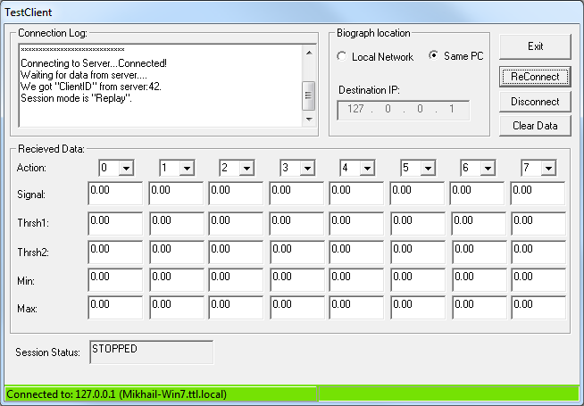

Figure 1. TestClient dialog.

Actual Implementation.

Before connecting to Biograph, you must call cxcInitialize(). This must be done only once. In order to do that, you make the following call:

BOOL ret = cxcInitialize( CXC_VER );

The best place to do that in OnInitDialog() function of your dialog(if you have dialog based MFC application).
If you do not want to use default TCP port (1000), you can set your own by calling

cxcSetPort( m_uiPort);

After that, we need to connect to a server by calling:

BOOL bRet = cxcConnect(strTargetIP);

If it returns true, it means that everything is fine and a connection has been established. If it returned false, then you cannot do anything, and you have to find the reason why connection has failed (wrong IP, port number or server is not running).
After that, we can start collecting data. The best way to set it up is to create a timer that would read latest values from Biograph.
First, you call

long nResult = cxcGetStates( g_aActionStates, &cStates, 0 );

and check if connection is lost or not, and the same time, if there is no connection lost, you get g_aActionStates array filled with latest signal data including the last sample value.
In order to get the whole sample array you can call

BOOL bRes = cxcGetActionData ( iAction, MAX_BUFFER, aBuffer, &cRead, &cLost );

copy aBuffer to g_aActionData[iAction]:
CopyMemory(g_aActionData[iAction], aBuffer, cRead * sizeof(float));
g_aActionData is array of the latest signal data sample values for each action.
In order to get latest formats (min, max, thresholds) that correspond to each action, you make the following call:

cxcGetFormats( g_aActionFormats, &cFormats, 0 );

In order to get information when a session is paused or stopped, you call:

BOOL bRet = cxcGetSessionState( &nSessionState );

There is a special session state “Frozen”. This can happen only in Recording. This is the case when display is frozen but the data is being recorded by Biograph. However, for Connection Clients it is the same case as Paused.

After, all is done you must call cxcDisconnect() and then cxcTerminate().

SampleFlash Player.

The main difference between TestClient and SampleFlashPlayer samples is that SampleFlashPlayer hides implementation related to Connection Client API. But this application serves specific purpose. It is intended to be used with Flash movies. That means that Flash developers can concentrate on the developing Flash games and not to worry about implementing Connection Client API as Player takes care of that, loads any custom Flash movie and then forwards necessary data to Flash.
Status bar of SampleFlashPlayer dialog displays the status of connection. Green status bar and string “Connected to <PC name>” mean that connection is established. Red status bar and string “Disconnected” indicate that there is no connection between BioGraph and SampleFlashPlayer.

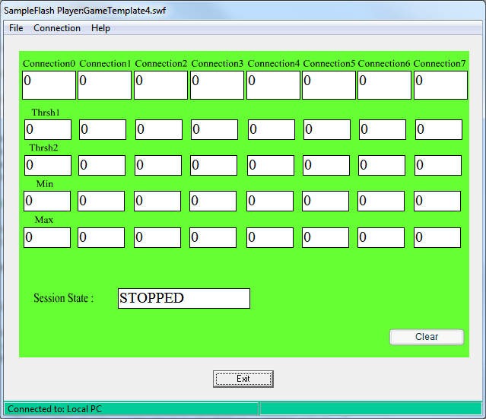

Figure 2. SampleFlash Player dialog.

It is possible to start Biograph on one PC and then SampleFlashPlayer on another PC on the LAN, and then connect to Biograph. In order to do that, choose “Connection” from menu and then click on “Connect to PC”. Then there will be “Select Computer” dialog that lets you select another PC. If target PC belongs to a workgroup, you need to select a workgroup first and then computer name. If SampleFlashPlayer will be running on the same PC with Biograph, just check “Connect to my computer”.

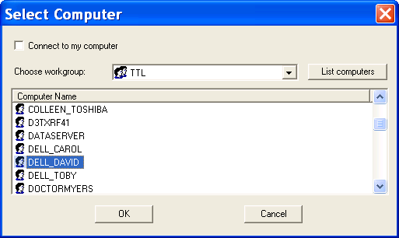

Figure 3. Select Computer dialog.
It is possible to start SampleFlashPlayer with a name of the flash movie to load as command line parameter. If you use this option to start SampleFlashPlayer, you cannot select another Flash movie from the menu.

Necessary modifications to Flash movies.

In order to make your Flash movie able to receive data from SampleFlashPlayer, there are a few conventional rules to follow.
First, in your Flash game you need to declare a set of global variables that will be accessed by both SampleFlashPlayer and your Flash game. The best place to do that is a piece of code that will be executed once. For example Init() frame. Since SampleFlashPlayer will send data as strings (Flash interface design), it is better to declare strings for each signal. Then, before using the signal you can convert string to a number. For example you can do it the following way:

if (!isNaN( parseInt( g_strSignal0 ) ) )
g_fSignal0 = parseInt( g_strSignal0 );

So, here are all strings for signals:

var g_strSignal0:String = "0";
var g_strSignal1:String = "0";
var g_strSignal2:String = "0";
var g_strSignal3:String = "0";
var g_strSignal4:String = "0";
var g_strSignal5:String = "0";
……..
var g_strSignal63:String = "0";

These variables are the associated thresholds for each connection. Please note, that there could be two thresholds per connection.

var g_strThreshold0_1:String = "0"; // connection 0; threshold 1
var g_strThreshold0_2:String = "0"; // connection 0; threshold 2
var g_strThreshold1_1:String = "0"; // connection 1; threshold 1
var g_strThreshold1_2:String = "0"; // connection 1; threshold 2
var g_strThreshold2_1:String = "0"; // connection 2; threshold 1
var g_strThreshold2_2:String = "0"; // connection 2; threshold 2
…………
var g_strThreshold63_1:String = "0"; // connection 63; threshold 1
var g_strThreshold63_2:String = "0"; // connection 63; threshold 2

The following are the strings that correspond to minimum and maximum scales of a connection.

var g_strScaleMin0:String = "0";// connection 0
var g_strScaleMax0:String = "0";// connection 0
var g_strScaleMin1:String = "0";// connection 1
var g_strScaleMax1:String = "0";// connection 1
…….
var g_strScaleMin63:String = "0";// connection 63
var g_strScaleMax63:String = "0";// connection 63

Now all the variables are defined. The way, data transfer between SampleFlashPlayer and a Flash movie works is the following. SampleFlashPlayer has callback functions for each connection, which are updated regularly by Connection Server object. Then, Flash move has its own loop with specific update frame rate. So, what Flash movie needs to do is to request from SampleFlashPlayer to update its variables. It is very important to do it this way. The other way is constantly sending new data to Flash. But this method would eventually crash Flash movie as there are some know problems with Flash interface. Flash can request new data by making following calls at each new frame:

fscommand (String command, String parameter);
Where :
command: name of the command.
Possible values:
- use “GetNewData” to get latest data.
parameter: name of connection.
Possible values:
- “Connection0” for first connection.
- “Connection1” for second connection.
………….
- “Connection7” for eighth connection e.t.c.
- “ConnectionALL” for all connections.
Examples:
fscommand ("GetNewData", "Connection0");
fscommand ("GetNewData", "Connection1");
fscommand ("GetNewData", "ConnectionALL");
If you want to get all latest data for all connections use “ConnectionALL’ as a parameter. However, if you only need data for one specific connection, use “ConnectionN”, where N is number of that connection. This way it will not create extra overhead by transferring unnecessary data between SampleFlashPlayer and Flash movie.
Please note, that it is not necessary to copy your Flash movie into Externals folder of the Biograph. You can open it from any location by using menu option from SampleFlashPlayer. However, you must copy SampleFlashPlayer.xml into Externals folder of the installation directory of Biograph. Also, you need to copy SampleFlashPlayer.exe and ConnectionClient.dll to the folder of your choice; and then make sure your provide path to that folder in <Path> tag of the XML file. XML file is needed for Screen Editor when you would be setting up your Connection Instrument.
In Screen Editor, when new Connection Instrument is placed on the screen, you need to choose “SampleFlashPlayer” as target application and then define all necessary settings and data type for future transfer. For more information see “Using your application with Biograph”.

Using your application with Biograph.

General principals of integrating with Biograph.

In order to use your application or you game with Biograph, there are a few things you need to do.
First thing, of course, is to create a game. Second, create XML file that would list all the actions that the game is going to use. For more detailed explanation on how to do it, see Creating game XML file.
Then the XML file must be copied into “Externals” folder of Biograph. If there is no “.\Externals” folder, you can create one yourself in the root of data directory of Biograph. It should look like this on XP: “C:\Documents and Settings\All Users\Application Data\Thought Technology\Infiniti\Externals”; and on Vista/Windows7: “C:\ProgramData\Thought Technology\Infiniti\Externals’. If you have a corresponding bitmap for your game, copy it in “..\Externals\Snapshots” folder. It will be shown in “Select Target Application” dialog.
Then, if you want your game to be run from the same PC as Biograph, you need to copy executable and ConnectionClient.dll into a folder of your choice (or perform your custom installation procedure). If you plan to use your game from another PC, do the same thing on that PC. Always keep in mind that ConnectionClient.dll must be in the same directory with the executable for your game.
VERI IMPORTANT: When you copy or install your game, do not depend on the ConnectionClient.dll that comes with Biograph! Always make sure, you copy your game with ConnectionClient.dll that you got with SDK you had used.
If you intend to use alternative TCP port number for establishing connection, you need also to make sure you have the same values in XML(to be used by Biograph) and to use cxcSetPort with the same port number.
Now, when everything is in place; we need to create or use existing screen to place Connection Instrument. Connection Instrument serves as Connection Server object in Biograph. It is initialized as a server (or producer) and listens for in coming connections from third party applications (games). When you put Connection Instrument on the screen, it will list all XML files in “Externals” folder and will let you choose the file you want. Then, you need to define connections between game actions and existing instruments. That means that, Connection Instrument uses output from Instruments and not from channels. There could be only one Connection Instrument per screen. When you define connections for game actions, you could choose different transfer mode for this particular connection. The choices are: Full, Boolean, Percentage. You have two ways to define connection transfer modes. You can specify them in xml file, or if you do not specify in xml and use Connection Settings dialog. Please note, that if you use xml to specify transfer modes, you cannot change them later in Biograph. You can do it only in your XML.
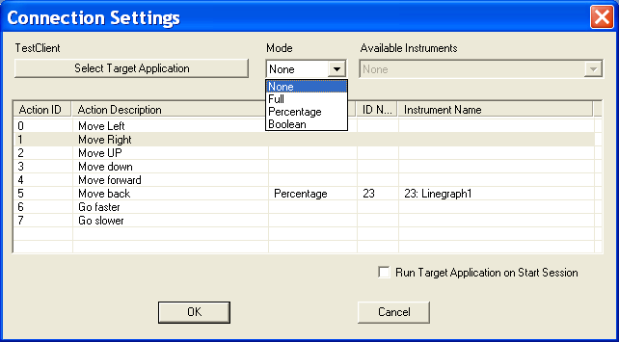

Figure 4. Settings dialog for Connection Instrument.

In Full mode, we send all information that is available: signal value, scale values and threshold values. Signal values are sent continuously, whereas scale and threshold are sent only when they have been changed.
In Boolean mode, we send only 0 or 1 depending on the signal value compared to threshold (s).
In Percentage mode, we send signal as a percentage value according to Scale, and threshold value(s) as percentage as well. Percentage value is calculated according to the following formula:
Signal – ScaleMin
ScaleMax – ScaleMin

When you choose your transfer mode, Instruments list is populated with all possible instruments whose signal output can be used. For example, if you choose Boolean mode, you will be able to choose only those instrument that have threshold(s). Please note that not all instruments can be selected by Connection Instrument. These are the instruments that can be selected: Bar graph, Single Line graph, Growing Shape, Scale, Percentage and Link. It is possible to select the same instrument for different game actions. “Run Target Application on Start Session” check box allows you to start your game automatically on the same PC as Biograph. Similarly, the game will be closed automatically when Session is closed. That is it for Screen Editor.
In Main Application, when screen is opened, Connection Instrument initializes Connection Server object and puts it in waiting mode (Listen to calls). Background of Connection Instrument becomes yellow and it is ready for incoming connections. If you did not select to start your application automatically, now it is the time to do it. You can do it manually on the same PC or from another PC on a network. If you chose to start your game automatically, Connection Instrument would read path to target application from tag <Path> from XML file. If there are arguments, there will be attached to command line and required application would be started. If connection is established, background color of the Instrument becomes green; and when you start the session, data will start flowing to the game. All data is sent by TCP

Creating game XML file.

Here is the content of SampleFlashPlayer.xml file that is used with provided sample application. The names of executable and associated with it XML file do not have to be the same. You would need to create your own XML file for each your game, and copy it into Externals folder of the PC running Biograph. In order to create or edit XML file, you can use Notepad.

<?xml version="1.0"?>
<!--TransferMode:Full(1),Percentage(2),Boolean(3)-->
<TargetApplication>
<Title>Sample Flash Player that plays Flash movie</Title>
<Snapshot>SampleFlashPlayer.bmp</Snapshot>
<Path>C:\ProgramFiles\Games\SampleFlashPlayer.exe</Path>
<Arguments>GameTemplate4.swf</Arguments>
<TCPPort>1000</TCPPort>
<Action>
<ID>0</ID>
<Description>Move Left</Description>
<TransferMode>1</TransferMode >
</Action>
<Action>
<ID>1</ID>
<Description>Move Right</Description>
<TransferMode>2</TransferMode >
</Action>
<Action>
<ID>2</ID>
<Description>Move UP</Description>
<TransferMode>3</TransferMode >
</Action>
<Action>
<ID>3</ID>
<Description>Move Down</Description>
<TransferMode>1</TransferMode >
</TargetApplication>

Table 1. Sample XML file.

If you had created your game with previous versions of SDK, you would not have <Path>
tag in your XML file. We added simple program that adds (or updates) <Path> tag with a path name into existing XML file. This program is called AddPath.exe and can be found in Utilities folder. It lets you to choose location of your game and then auto determines the XML file that would be updated. When you want to add paths to sample applications from SDK, just browse for the file in SDK folder and that path would be added to XML file. After choosing target application, AddPath program automatically matches the name of XML file. If XML filename is not correct, you can change it by clicking button “Change”. Here is the snapshot of that program:
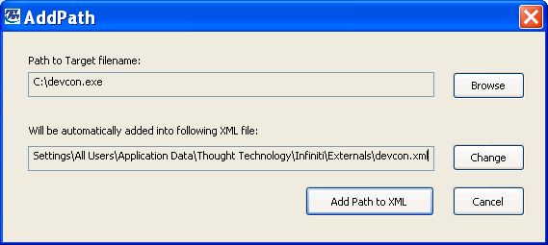

In this table you can find explanation of each particular tag of our XML file. Please, keep in mind that it is very important to follow the same structure pattern for this file and also to make sure the XML file is valid (i.e. it should open in Internet Explorer without any errors).

XML Tags | Optional | Description
<TargetApplication> | No | Encloses all information
<Title> | Yes | Alternative name of the game.
<Snapshot> | Yes | Bitmap filename used to represent the game in Select Target Application dialog of Screen Editor. You can leave the content of this tag empty if you do not have any bitmaps
<TCPPort> | Yes | Port number to be used by Server. 1000 is default.
<TransferMode> | Yes | Specific mode for an action. If specified in XML, it cannot be changed in Screen Editor. If there is at least one mode defined in XML, then you have to specify modes for other actions as well. Possible values are: Full=1, Percentage=2, Boolean=3.
<Path> | No | Full path to a target application.
<Arguments> | Yes | Optional arguments that will be passed to target application on auto start up.
<Action> | No | Encloses description of one action. You can have up to 64 actions. At least one action must be defined.
<ID> | No | ID of an action. Must be from 0 to 63.
<Description> | No | Short description of an action that will be displayed in Screen Editor.

Table 2. XML tags.

